DSA0502 – Query Processing for Data Science
Course Faculty | Dr. B .SHYAMALA GOWRI
Reg. No. | 192324164
Student Name | Sweety Roselin A

CO1 – AT1 – Data Interpretation
Question 1 . Read datasets from CSV, JSON, and XML formats. Inspect the datasets, handle missing values, remove duplicate records, validate data types, merge related CSV datasets using a common key, perform aggregation and summary statistics, identify the category with the highest value, and export the cleaned dataset to a new CSV file.
Aim : To read customer datasets from multiple file formats, clean and validate the data, merge related datasets, perform data analysis, and export the cleaned dataset using Python and Pandas.

Program (Python)
import pandas as pd
import xml.etree.ElementTree as ET
customers = pd.read_csv("Customers.csv")
regions = pd.read_csv("Regions.csv")
customers_json = pd.read_json("Customers.json")
tree = ET.parse("Customers.xml")
root = tree.getroot()
xml_data = []
for customer in root.findall("Customer"):
xml_data.append({
"CustomerID": customer.find("CustomerID").text,
"Name": customer.find("Name").text,
"RegionID": customer.find("RegionID").text,
"Category": customer.find("Category").text,
"Amount": float(customer.find("Amount").text)
})
customers_xml = pd.DataFrame(xml_data)
print(customers.head())
customers.fillna("Unknown", inplace=True)
customers.drop_duplicates(inplace=True)
customers["Amount"] = pd.to_numeric(customers["Amount"])
merged = pd.merge(customers, regions, on="RegionID")
summary = merged.groupby("Category")["Amount"].sum()
print(summary)
print("Highest Category:", summary.idxmax())
merged.to_csv("Cleaned_Customers.csv", index=False)
print("Cleaned dataset exported successfully.")

Input
Customers.csv
CustomerID,Name,RegionID,Category,Amount
C101,John,R1,Gold,12000
C102,Alice,R2,Silver,9000
C103,David,R1,Gold,15000
C104,Emma,R3,Platinum,18000
Regions.csv
RegionID,Region
R1,Chennai
R2,Bangalore
R3,Hyderabad
Customers.json
[{"CustomerID":"C101","Name":"John","RegionID":"R1","Category":"Gold","Amount":12000}]
Customers.xml
<Customers>
<Customer>
<CustomerID>C101</CustomerID>
<Name>John</Name>
<RegionID>R1</RegionID>
<Category>Gold</Category>
<Amount>12000</Amount>
</Customer>
</Customers>

Output

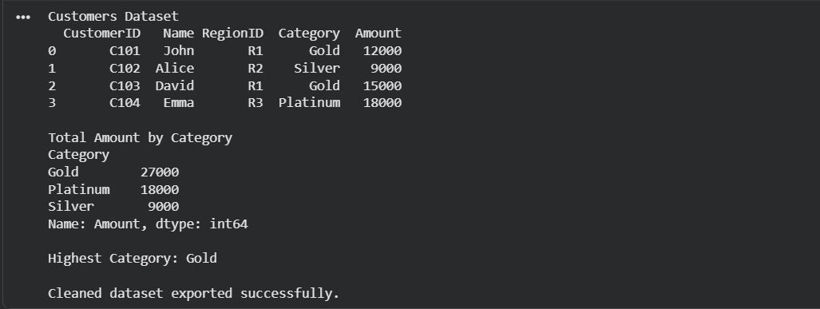Result
Thus, the customer datasets from CSV, JSON, and XML formats were successfully read, cleaned, validated, merged, analyzed, and exported to a new CSV file successfully.

Question 2 : Read employee datasets from CSV, JSON, and XML formats. Inspect the datasets, handle missing values, merge the CSV datasets using Department ID, calculate salary statistics, perform department-wise aggregation, identify the department with the highest average salary, and export the cleaned dataset.

Aim : To read employee datasets from multiple file formats, clean and validate the data, merge related datasets using Department ID, perform salary analysis and department-wise aggregation, identify the department with the highest average salary, and export the cleaned dataset.

Program (Python)
import pandas as pd
import xml.etree.ElementTree as ET
employees = pd.read_csv("Employees.csv")
departments = pd.read_csv("Departments.csv")
employees_json = pd.read_json("Employees.json")
tree = ET.parse("Employees.xml")
root = tree.getroot()
xml_data=[]
for emp in root.findall("Employee"):
xml_data.append({
"EmployeeID": emp.find("EmployeeID").text,
"Name": emp.find("Name").text,
"DepartmentID": emp.find("DepartmentID").text,
"Salary": float(emp.find("Salary").text)
})
employees_xml = pd.DataFrame(xml_data)
employees.fillna("Unknown", inplace=True)
employees.drop_duplicates(inplace=True)
employees["Salary"]=pd.to_numeric(employees["Salary"])
merged=pd.merge(employees,departments,on="DepartmentID")
summary=merged.groupby("DepartmentName")["Salary"].mean()
print(summary)
print("Highest Average Salary:",summary.idxmax())
merged.to_csv("Cleaned_Employees.csv",index=False)
print("Cleaned dataset exported successfully.")

Input
Employees.csv
EmployeeID,Name,DepartmentID,Salary
E101,John,D1,50000
E102,Alice,D2,60000
E103,David,D1,55000
E104,Emma,D3,70000
Departments.csv
DepartmentID,DepartmentName
D1,HR
D2,IT
D3,Finance
Employees.json
[{"EmployeeID":"E101","Name":"John","DepartmentID":"D1","Salary":50000}]
Employees.xml
<Employees>
<Employee>
<EmployeeID>E101</EmployeeID>
<Name>John</Name>
<DepartmentID>D1</DepartmentID>
<Salary>50000</Salary>
</Employee>
</Employees>

Output

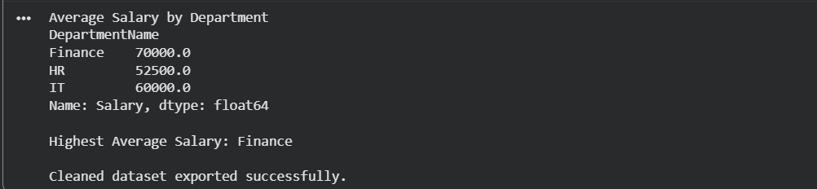Result
Thus, the employee datasets from CSV, JSON, and XML were successfully read, cleaned, merged using Department ID, salary statistics and department-wise aggregation were performed, the department with the highest average salary was identified, and the cleaned dataset was exported successfully.

